**Simple Query database Apotik**

1. **SELECT * FROM `obat` ORDER BY nama DESC;**

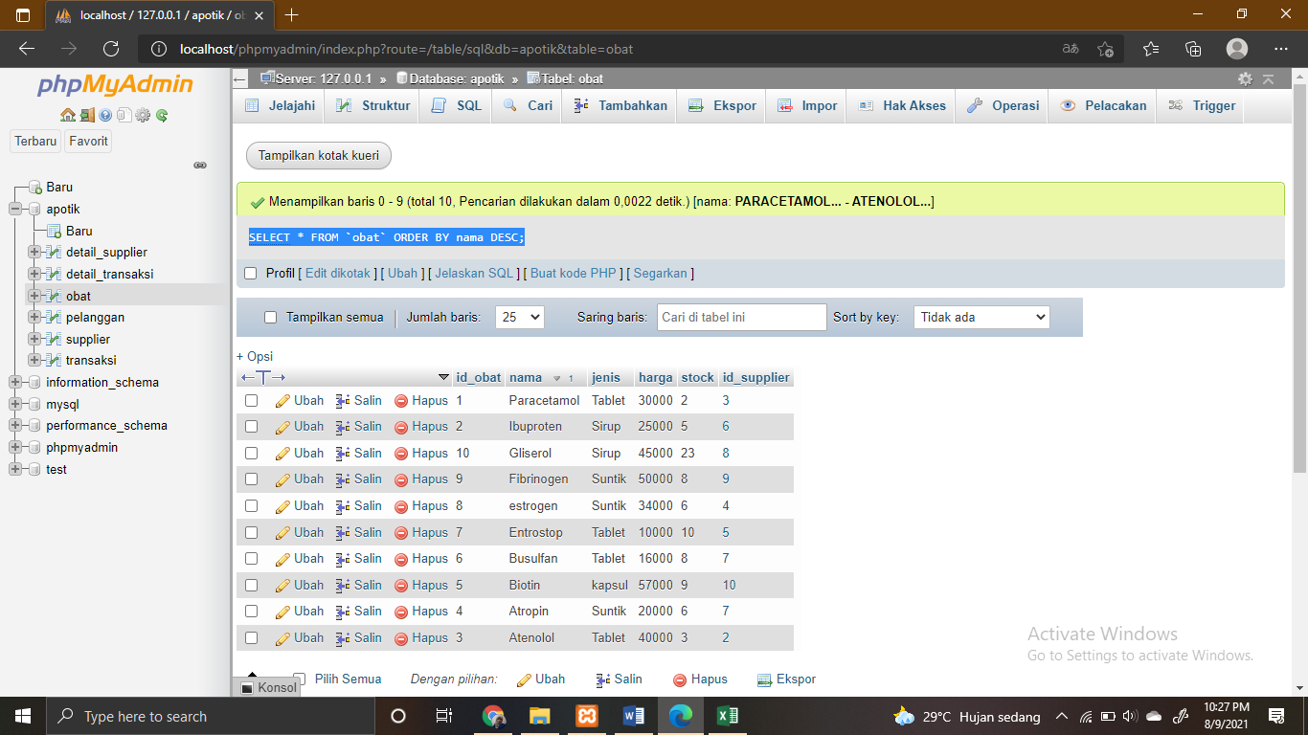

1. **SELECT * FROM `obat` ORDER BY nama ASC**

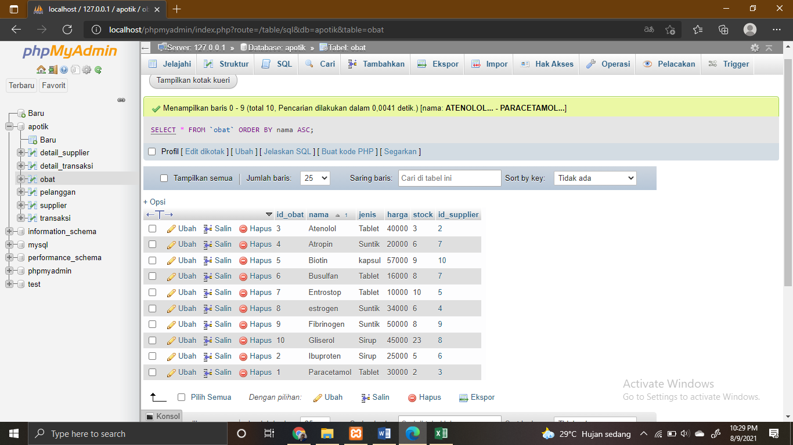

1. **SELECT * FROM `tb_obat` WHERE nama_obat LIKE '%Kalpanak%'**

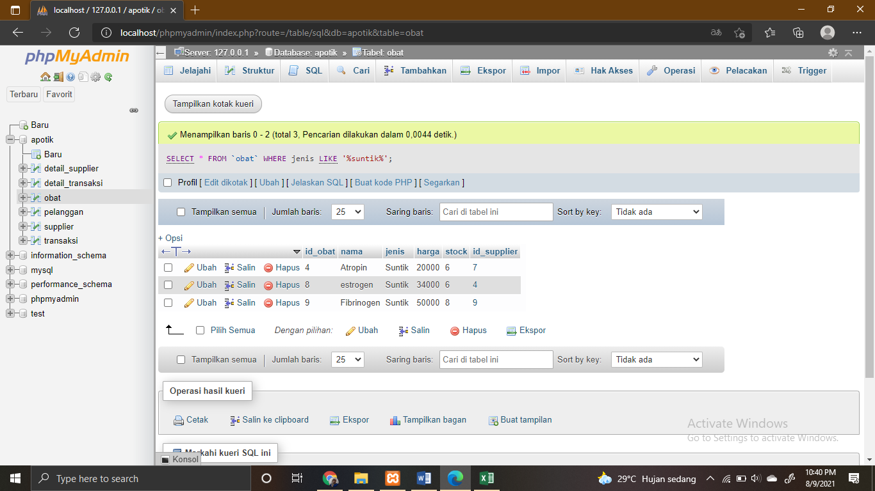

1. **SELECT * FROM `supplier` WHERE nama_supplier LIKE '%Kimia%'**

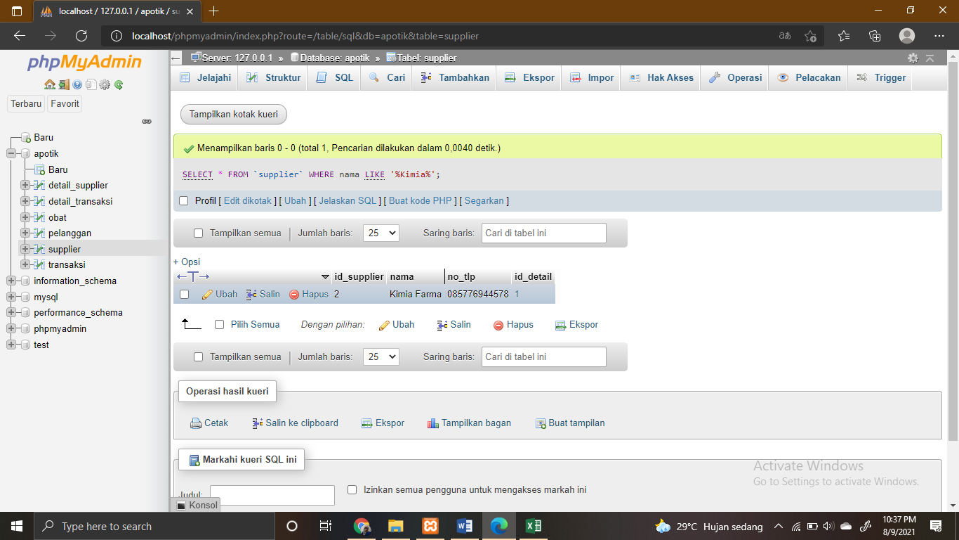

1. **SELECT jenis, SUM(stock) as total FROM `obat` GROUP BY jenis;**

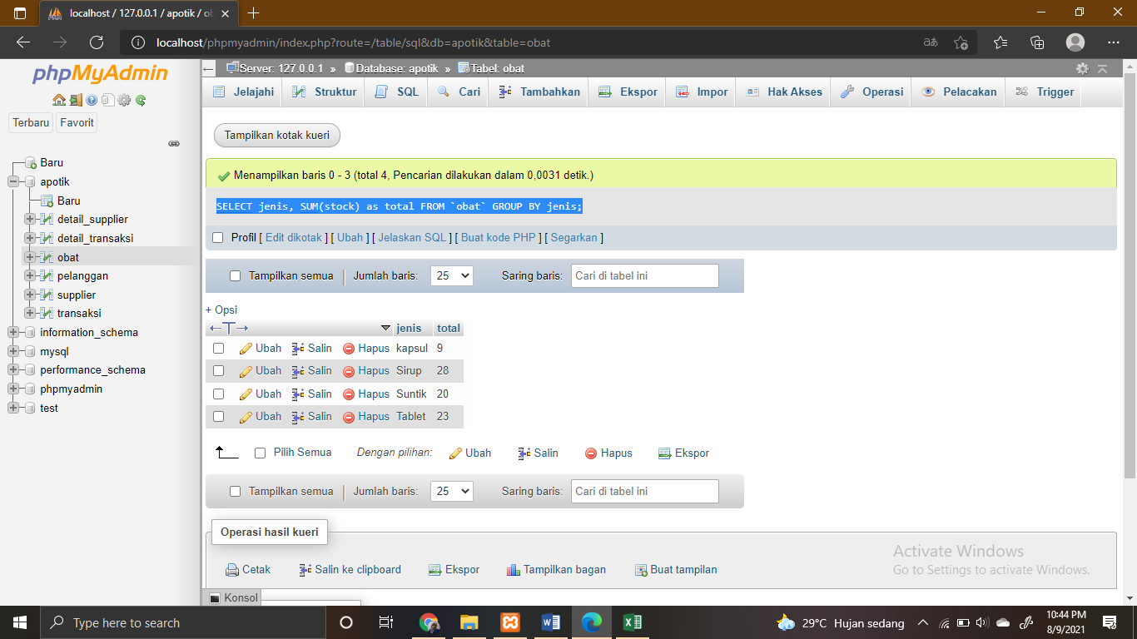

1. **SELECT id_supplier, SUM(stock) as total FROM ` obat` GROUP BY id_supplier**

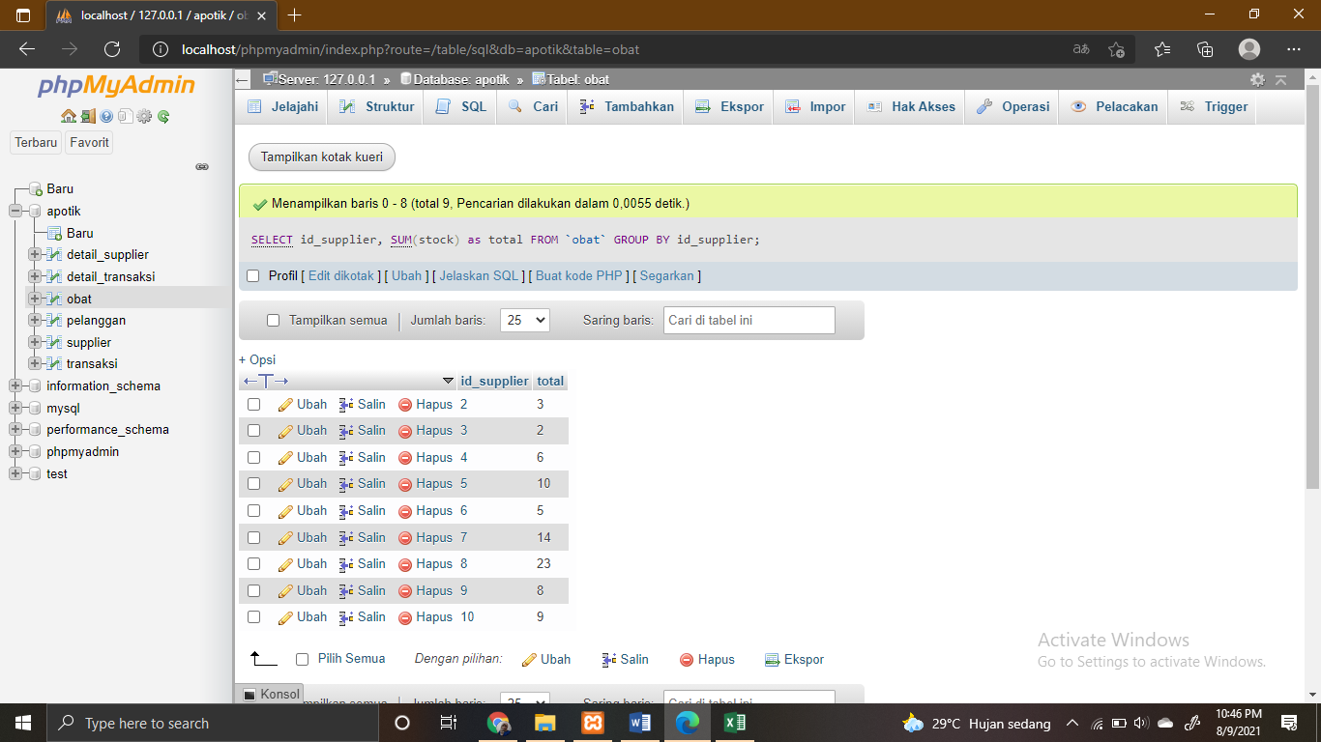

1. **SELECT * FROM `pelanggan` WHERE alamat LIKE '%Tangerang%'**

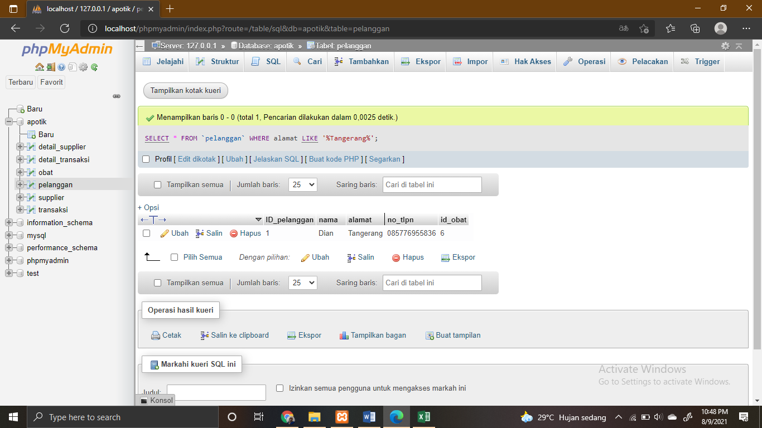

1. **SELECT * FROM `transaksi` WHERE tgl_transaksi LIKE '%2021-08-03%';**

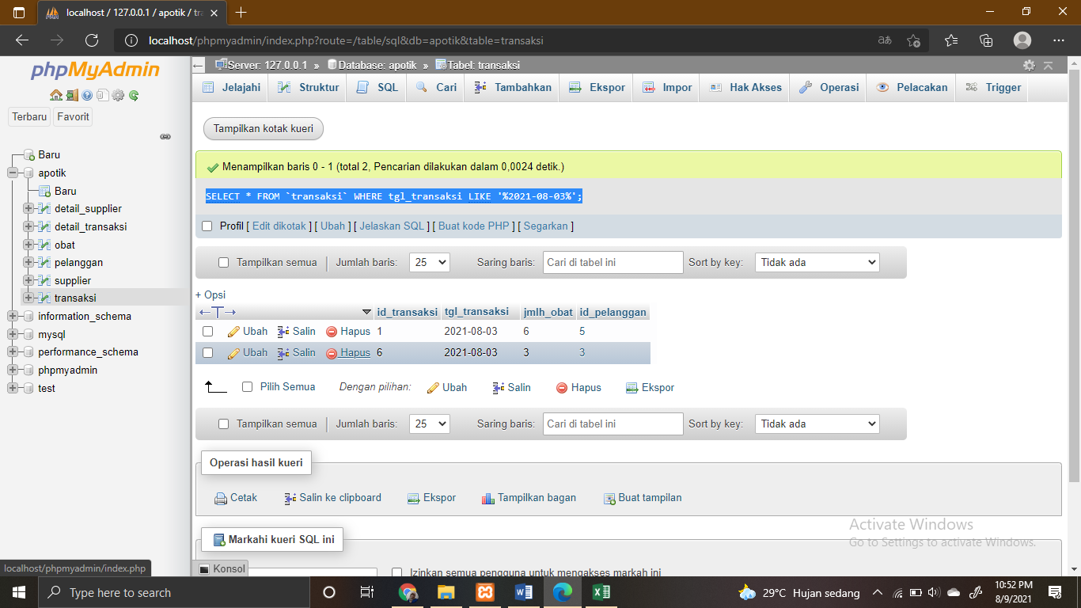

1. **SELECT * FROM `obat` WHERE harga >=30000 ORDER BY nama ASC;**

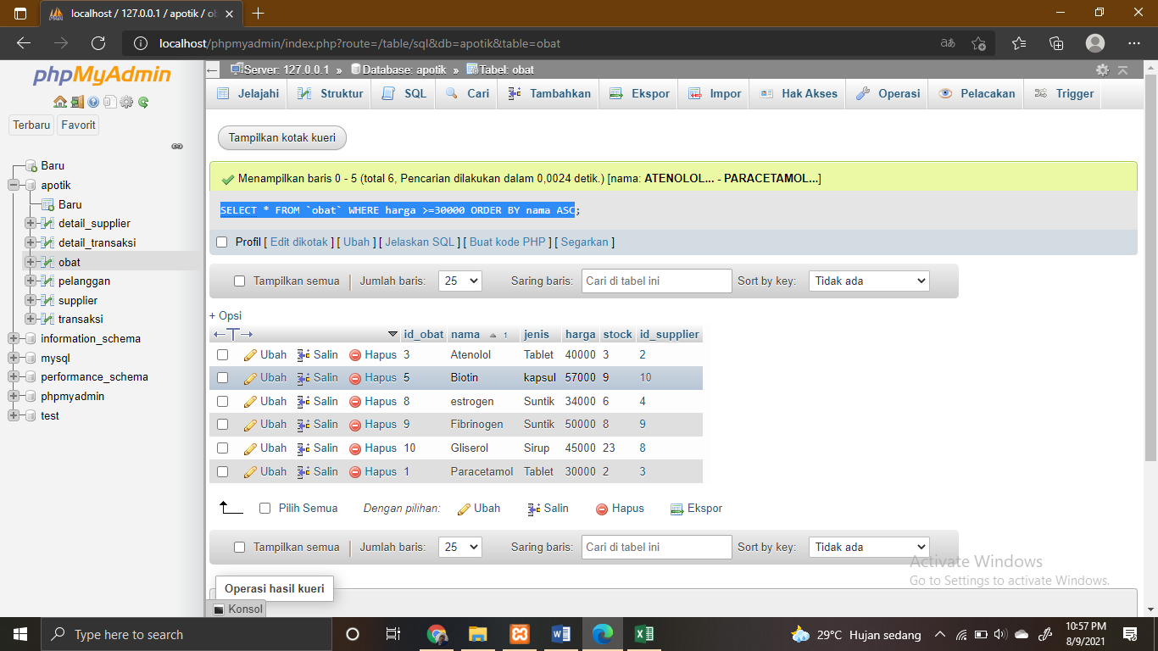

1. **SELECT jenis, SUM(stock) as total FROM `obat` GROUP BY jenis ORDER BY jenis DESC;**

